Rubric - Beauty

Hed: 3 ways to keep your skin looking vibrant without surgery
Make image ½ of first page
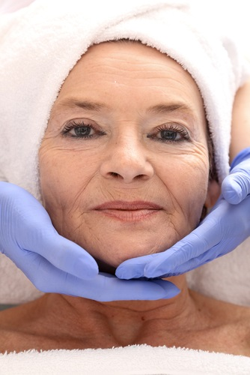
BY WENDY PACKER AND DR. STACIE MCCLANE
For those readers who don’t know me, I am a Registered Nurse. In 2007, I took a series of courses in Aesthetic Nursing which included topics such as: 1) general knowledge of cosmetic procedures., 2) laser procedures; 3) botox and fillers; and 4) dermabrasion, facials, and derma blading, along with other procedures that have since become more advanced.
My co-author is Dr. Stacie McClane who is a Board Certified Crania-Facial Plastic Surgeon. Dr. McClane is one the foremost specialists in performing non-invasive and surgical procedures to patients ranging from deformities and to cancer, to cosmetic procedures. Dr. McClane performed the procedures you will see in the photos.
#1 Topical Products
Topical products are the easiest thing you can do for your face. It may take an office visit to your doctor to get a prescription if you want medical grade quality products, but after that, all it takes is your diligence in application. Medical grade products will give you the fastest and most potent effects, but there are less potent products on the market that will give you some results.
Retin-A 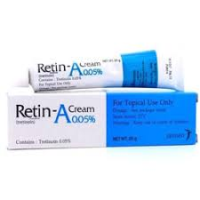
Despite all of the claims made by the millions of skin products on the market, there is primarily one product that is the gold standard in building collagen, and that is Retin-A. Retin-A is a derivative of Vitamin A which dermatologists were initially prescribing for acne. Accidentally it was discovered that it also helped the skin look firmer, smoother and younger looking. Today there is overwhelming evidence-based data proving this.
Retin- A works by increasing the skin’s cell turnover, which then stimulates collagen production. Increasing cell turnover can also prevent new wrinkles from forming and reverse sun damage. In order to obtain medical grade Retin-A, you will need to see your physician for a prescription. There are other over the counter products that contain smaller doses of Vitamin A, referred to as retinol, but getting prescription strength will in the long term save you money.
Glycolic Acid and other peeling agents - Application of dermatological topical acids, such as glycolic acid will also increase cell turnover, however, at a much slower rate than Retin-A. Again, anything purchased over the counter will be very mild and results will be slow. You can, however, go to your physician’s office and have a more aggressive peel under safer circumstances.
Hydroquinone and Kojic Acid - These two products are bleaching agents meant to reduce/eliminate age spots, or darkened pigmentations of the skin (They will not work on discoloration due to hormonal imbalances.) Hydroquinone in strong doses over a prolonged period has been linked to a certain type of cancer, so use of this must be monitored closely by your physician. Kojic Acid, however, is another milder organic substance that can also be used. It is sometimes preferred by physicians.

#2 Exfoliation/Facials
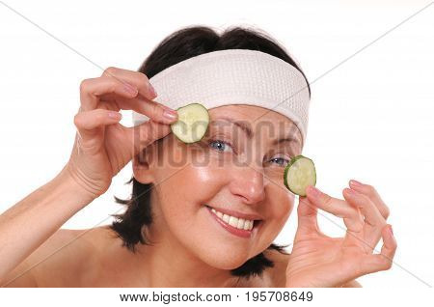
Scientific evidence has proven the effectiveness of exfoliation on the production of collagen. Exfoliation can range from using over the counter soaps containing abrasive products to more aggressive procedures performed in your doctor’s office.
My person favorite is using a simple washcloth and scrubbing mildly. That way I can feel the amount of pressure, which you don’t want to do excessively.
Another even more effective modality are facials. Again, the strongest and most effective facials you can get are at your doctor’s or aesthetician’ s office. There are a wide variety of facials offered today which exceed the scope of this article. But, getting facials on a semi-regular basis does many things. They can: 1. Clean pores 2. Exfoliate dead skin, increasing cell turnover. 3. Prevent pores from clogging which can lead to those unsightly carbuncles you sometimes see in the movies.
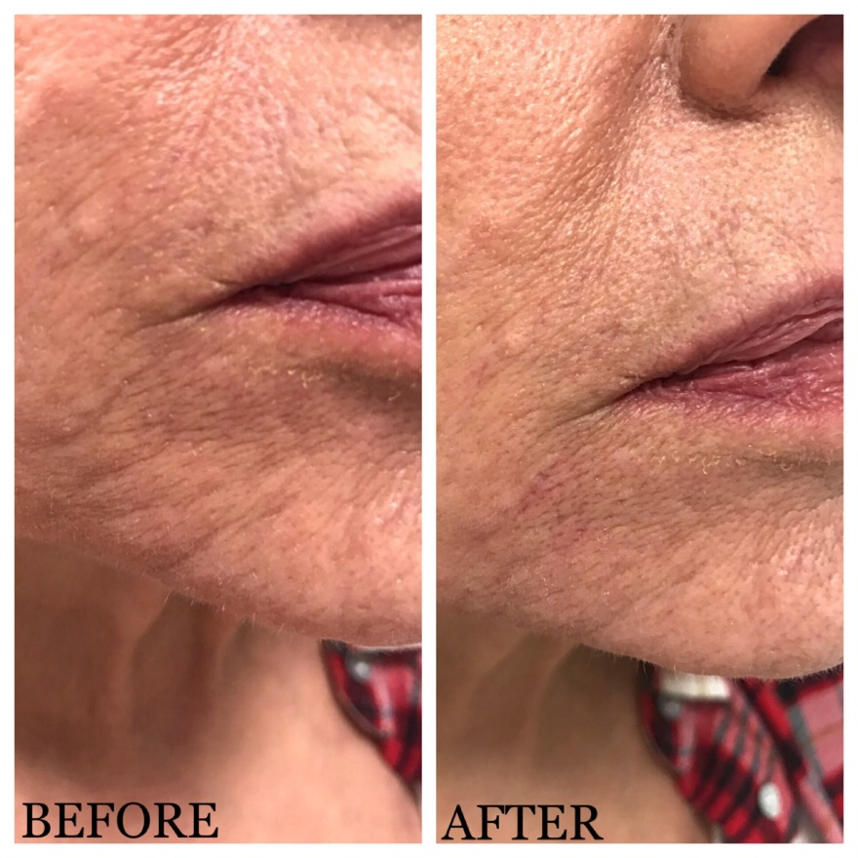
Caption: Actual photo of author, Wendy Packer
#3 Fillers and Botox
Hollywood has given a bad rap to both of these products because we have seen actresses who have used them so aggressively that their faces have become almost unrecognizable. However, done in moderation and in good taste, they are very helpful, and should not be pooh-poohed. Fillers do exactly that. They can fill in wrinkles, scarring, and other abnormalities that may have occurred to the skin’s surface.
Personally, I have suffered from cystic acne since adolescence. At 64, I must be careful trying any new product, including moisturizers, or I will break out. As a result of the cysts, I have many scars, mostly around my chin and mouth. Fillers injected in to the scars have been very effective in diminishing the cragginess in my skin from the scars as you can see in
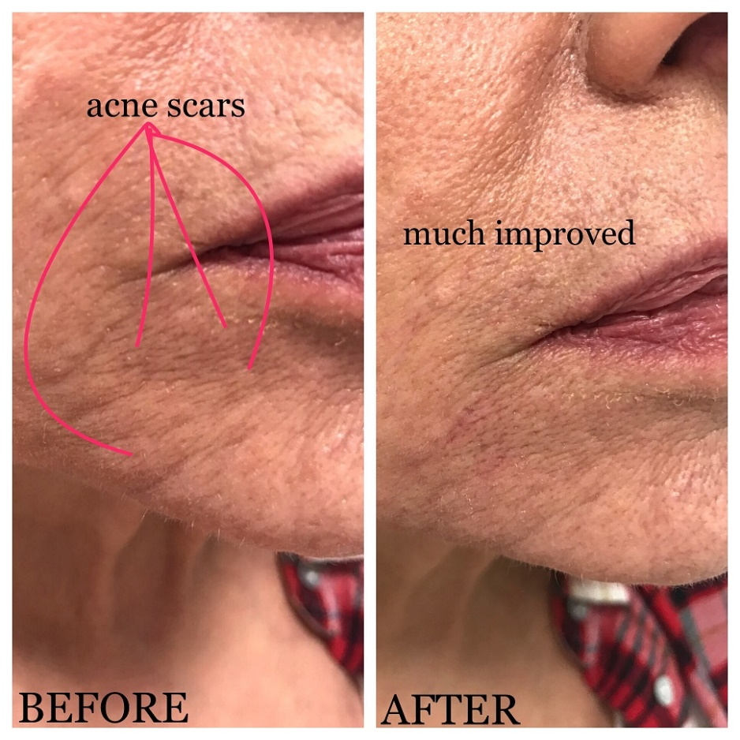.
Caption: These photos are of author, Wendy Packer. Dr. McClane injected the filler (Belotero) in to her acne scars which had left craters in her skin.
Again, Botox has a bad rap. The one place I like to use it is between my eyebrows, commonly known as the “11” lines. As women over fifty, you may be reluctant to try it, but I can tell you with first-hand knowledge that many women in their 30’s are using it to prevent wrinkles. Yes, maybe our society is becoming overly obsessed with looking young, but if you don’t want those “11” lines, it sure is effective.
In summary, these modalities are easy to do on an occasional basis, however, if you do them on a regular basis or as needed, your skin will start to look better and better.

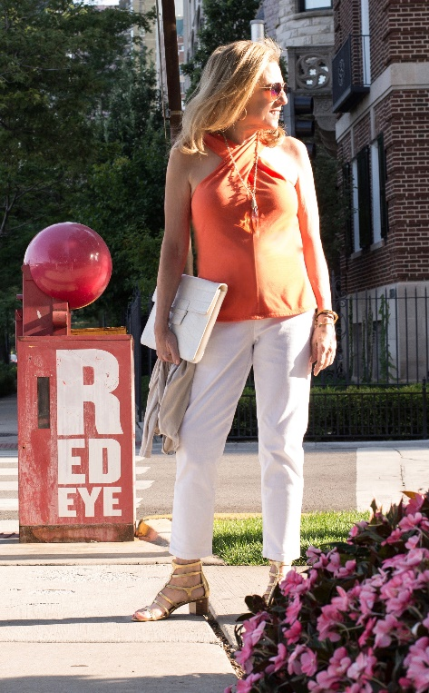
Author Bio WENDY PACKER - When I was 58, after raising my kids and sending them off to college, I started doing something I have been passionate about since I was little. I started to blog about fashion. My blog is FashionOverFifty.com. I have been championing the cause of getting retailers, designers, and advertisers to get over their "agism", and start including us. I also have produced fashion shows with women over 50 as models. Please contact me at wendy.fashionoverfifty@gmail.com or join me on my Facebook page

