[rubric] invisible grands

Hed: Keep the faith

BY PAT HANSON, PH.D.
Does the restoration of friendly relations in your family seem impossible? Hold out hope; reunion can and does happen. It may start with an amends letter, a phone call to show you care, or even news of a relative’s death. As Wayne Dwyer said, “If you believe it, you’ll see it.”
An alienated grandmother’s success story

Crop and enlarge pic
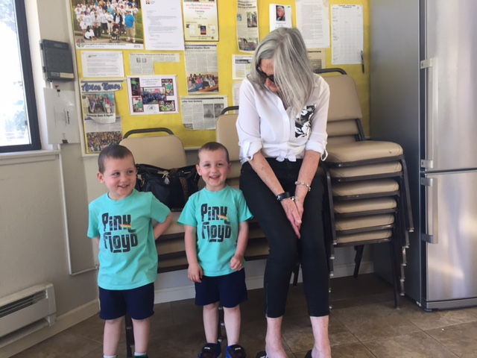

Roberta found www.invisiblegrandparent.com online. She was devastated. She’d been at the birth of her daughter Carol’s twin boys on Valentine’s Day 2014, but hadn't seen them since.

CALL OUT: “She was a tough teen to raise, all her boyfriends were losers.”

“She was a tough teen to raise,” Roberta said. “All her boyfriends were losers. I’ve never allowed overnights in our home. Partly because Roberta would not allow Carol and her boyfriend to move into her home, they moved an hour away. For almost two years, her daughter did not answer multiple phone calls, letters or texts.

Then, Roberta’s brother, Carol’s uncle, passed away and to her surprise Carol, her partner, and twin sons showed up at the funeral. Mother and daughter began to communicate and even visited on Valentine’s Day 2016. But the visits didn’t continue. Whenever Roberta would call Carol would say she couldn’t talk, or she’d make a date and then break it at the last minute.

Roberta was losing hope and kept repeating, “She’s always chosen bad boyfriends, she’ll do it again.” We reminded her not to verbalize negative thoughts. At the close of every support group we offer prayers of hope, gratitude for the connections between members, forgiveness of others and ourselves, and call upon our faith to help us think of possibilities.

Call out: Carol discovered her boyfriend had cheated on her.

Recently, Carol discovered her boyfriend had cheated on her. She took her babies to her mom’s and for about six weeks Roberta was doing full-time childcare. She was exhausted yet thrilled to be a grandmother.

Carol sought a restraining order against the father of her twins because he’d been violent with her. Roberta accompanied Carol to court. Carol says her family is now her priority.

At first Roberta told me she felt embarrassed, even a little guilty to share her success with the group members, but I assured her she was an inspiration. Last month she brought the three-year-old twins and played with them quietly during the meeting.

SIDE BAR: Are you cut off from your grandchildren? 

Alienated Grandparents Anonymous (AGA) helps grandparents who want to be in the lives of their grandchildren by providing support and information. AGA originated in Collier County, Florida in September 2011 and is a 501(c)3. Since then they have grown to have a presence in 50 states and 18 countries.

AUTHOR BIO: PAT HANSON -PICK UP FROM LAST ISSUE

